
Sandwell Metropolitan Borough Council

Park Hill Primary School
Head Teacher: Mrs. C. L. Logan
Coronation Road
Wednesbury
West Midlands
WS10 0TJ
Telephone: 0121 556 2188
Email: office@parkhillprimary.co.uk

26th November 2025

Dear Park Hill Families


I wanted to inform you that we will be having electric gates fitted to the car park in December. Some families had got in touch with us as they were worried about our safety in school, as people walk under the barrier. It was already on our wish list, and we are now in a position to pay for them to be installed.

I would like to take this opportunity to remind parents not to park or turn around at the top of the drive, this compromises the safety of all children and pedestrians walking near to the school. Please find a safe place to park and walk to the school entrance.

We have also bought door jammers that will allow the classroom doors to be locked from the inside, in case of an emergency outside. We will be practising our lockdown procedures over the next few weeks and into the new term so please do not be alarmed if your children come home and say that we have had a lockdown drill.



I also ask if you have a worry or a concern, direct this to the class teacher in the first instance. Many worries can be sorted straight away with classroom staff.

If you need to take your concern further, then it would be:
- Miss Neale for EYFS
- Mr Booker for Key Stage 1
- Mr Dingle for Key Stage 2

Should you need to escalate further, the Deputy Head, Mrs Boardman, would be your next contact.

To escalate even further, it would then be the Head Teacher - Mrs Logan.

If, after you have spoken to Mrs Logan and you are still unhappy, you should contact our Chair of Governors through the Complaints Policy.

At school, we pride ourselves on being approachable and respectful to families. However, my staff and I are not here to be insulted, verbally abused, threatened, shouted at or disrespected. At school, we are saddened to note that we are experiencing more and more cases of this: it will not be tolerated.

I have attached our poster that is displayed in the foyer and on the website to show unacceptable treatment towards staff.
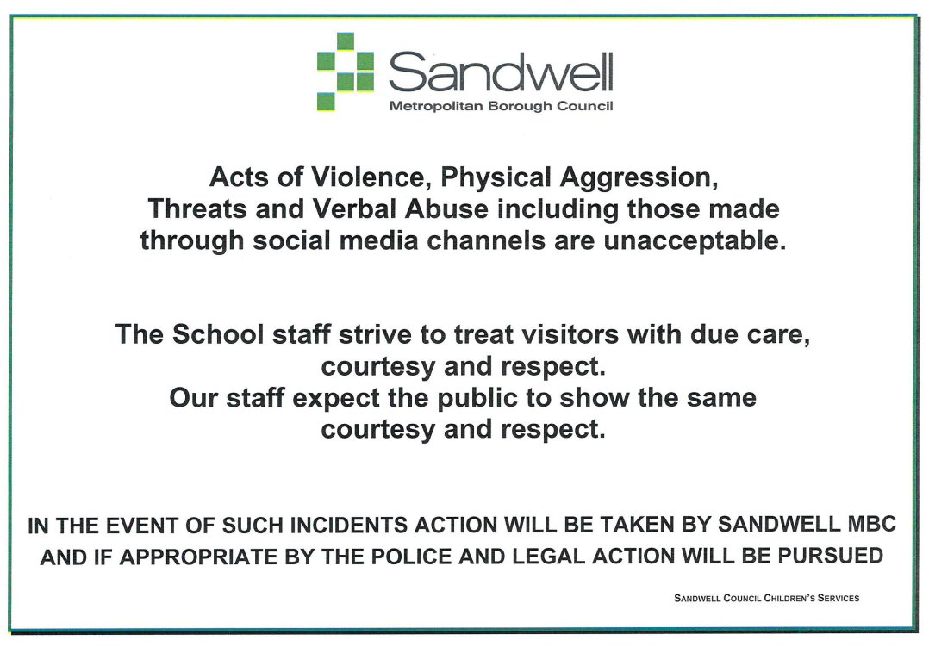
This includes communication:
- On the telephone
- In the foyer
- On the gates
- Via email
- At school events
Please note that our “Code of Conduct for Parents, Carers and Visitors” goes into more detail about how such incidents may be dealt with.
Both the Complaints Policy and Code of Conduct are available on our school website here: www.parkhillprimary.co.uk/complaints-and-conduct

Thank you for your continued support in making Park Hill a safe and respectful place to learn and work.

C. Logan
Head Teacher

