Park Hill Primary School

Admission Policy

For starting school in 2026-27

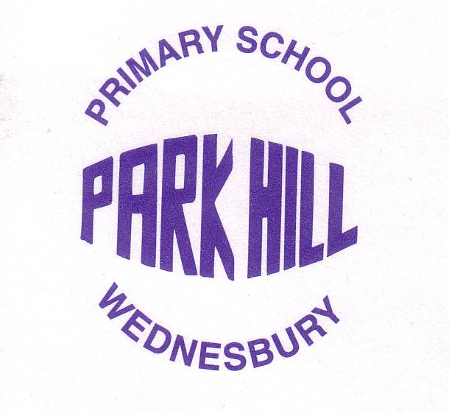

​Date Reviewed | ​January 2025
​Category | ​Statutory
​Next Review Date | Annual January 2026
​Policy Availability | ​School Website
Person Responsible | Mrs C. Logan

Policy Version Control

Date of Change | Details of Change
12.01.23 | Pg.2. – Raising 3’s removed

Park Hill Primary School is maintained by Sandwell Local Authority and is a Foundation School.

The Governing Body is responsible for deciding which applicants are offered places for admissions during the school year however, the Local Authority deal with the administrative process on the Governors’ behalf.

What You Need to Do

To ensure that you have the best chance to secure a place at one of your preferred schools, it is essential that you meet the admissions criteria for the school(s) as closely as possible. Make sure you look at the admission criteria for the schools you are interested in – home to school distance (straight line measurement) is one of the most common criteria to be applied so consider how closely your child lives to the school.

The distance of the furthest successful applicant will vary year by year depending on how many applicants there are, where they live and the number of applicants with siblings at a particular school.

Before confirming your preferred schools please also look carefully at any other criteria e.g.

- Looked After Children (LAC)
- Children with an Educational Health Care Plan (EHCP)
- Sibling connection
- Denominational criteria
- Aptitude criteria

Sandwell School Admissions Contact Details

https://www.sandwell.gov.uk/info/200303/school_admissions

We have a dedicated parent support line (0121 569 6765) Face to Face – if you feel you wish to see someone in person please contact the School Admissions Service via the parent support line.

Email:
Annual Admissions: annual_schooladmissions@sandwell.gov.uk

Mid-Year Admissions: midyear_admissions@sandwell.gov.uk

Appeals: schoolappeals_admissions@sandwell.gov.uk

Postal Address:

School Admissions Service
PO Box 16230
Sandwell Council House
Freeth Street
Oldbury
B69 9EX

Tel: 0121 569 6765

Applying for a Place in Nursery

All children are eligible for free nursery education at Park Hill Primary School in the term after their third birthday. You can apply from when your child is 2 years and 36 weeks old.

- Fifteen Hours

We continue to offer 15 hours of Nursery provision for all children. This runs from 8.30am – 11.30am.

- Thirty Hours

For parents who meet the criteria set out by the government, we offer 30 hours of Nursery provision. This runs from 8.30am – 11.30am then 12.30pm – 3.30pm. We do provide childcare for the hour’s lunch (11.30am-12.30pm) at a small extra charge of £5.00 per day.

It is the parents’ responsibility to apply for the 30-hour entitlement code ready for the beginning of each school term. Once you have received your code, please inform the school office.

For more information and to apply for 30 hours of provision, please visit

https://gov.uk/30-hours-free-childcare.

Nursery Application Forms

For all Nursery applications, please visit the school office to obtain an application form. Our Early Years Coordinator arranges the Nursery admission procedure and contacts you when there is a place available.

(Please be aware that having a place in a nursery class attached to a school does not guarantee a place in the reception class at that school.)

Applying for a Reception Place for September 2026

For children born between 1st September 2021 and 31st August 2022.

If your child attends Park Hill’s Nursery, you will be given an admissions letter produced by Sandwell Local Authority, which will give you details about how to complete the form online and, most importantly, the deadline for applications.

Children who have not attended our Nursery can apply for Reception.

Please note; Families applying for places in Reception classes should note that although children may already attend at the school’s nursery, this does not guarantee a place in Reception.

You can apply for up to six schools but please ensure that you complete only ONE form.

- Class Sizes

Parents applying for a place in Reception class should note the law governs the maximum size of classes in Key Stage 1 (Reception, Year 1 and Year 2). The law states that it is unlawful for a class in Key Stage 1 to have more than 30 pupils being taught by a single teacher, except in exceptional circumstances.

At Park Hill Primary School, the Published Admission Number (PAN) for our Reception class is 30 places.

Admissions Priorities

The school has adopted the LA Admissions Priorities. Where there are more applications for a school than places available, places will be allocated on the basis of the following priorities:

1. A ‘looked after child’ or a child who was previously looked after but immediately after being looked after became subject to an adoption, child arrangements, or special guardianship order including those children who appear to have been in state care outside of England and ceased to be in state care as a result of being adopted. A looked after child is a child who is (a) in the care of the local authority, or (b) being provided with accommodation by a local authority in the exercise of their social services functions as defined by section 22 (1) of the Children Act 1989 at the time of making the application for a school place.

2. Children with a particular medical condition. Applications submitted under this criterion must be accompanied by a medical declaration form (ASU75M) signed by the child’s General Practitioner or Consultant confirming the condition, detailing the child’s needs and specifying why, in their opinion, the preferred school is the only or most appropriate to meet the child’s needs. All applications under this criterion will be assessed by the LA to decide whether the child’s needs can be met most appropriately by the preferred school.

3. Children having a brother or sister at the preferred school (not nursery) at the time of admission.

4. Children prioritised by distance measured in a straight line from a child's home* to the school’s designated entrance (as determined by the Head Teacher). In all cases, should the number of applicants exceed the number of places available, places will be allocated on the basis of distance between home and school, as measured in a straight line from home to the main entrance to the school with priority being given to those living closest to the school.

* Measured from the Ordnance Survey Address point for the property.

Children who have an Education Health and Care Plan (EHCP) which names a particular school will be admitted to the school. This means that less places are available for other pupils.

Sandwell operates an equal preference policy. This means that we will treat each of your preferences as a first preference even though you have ranked them in order.

Changing Schools in the Middle of the Year

Mid-year applications are when you apply to transfer your child from one primary school to another primary school or from one secondary school to another secondary school during the school year.
If you wish to apply for a Sandwell school during the course of the school year, please download the relevant form and follow the instructions on the form from https://www.sandwell.gov.uk/info/200303/school_admissions/2053/changing_schools
Please contact Sandwell LA if you require any further help or information on how to change schools in the middle of the year.
Write to:
Admissions and Appeals Service
PO Box 16230
Sandwell Council House
Freeth Street
Oldbury
B69 9EX

Email: midyear_admissions@sandwell.gov.uk

The Appeals Process

- September Starts

If you are not happy with the school you have been offered, you may appeal. It is strongly recommended that you accept the school that has been offered to you even if you decide to appeal for your preferred school. By accepting the school offered, you will guarantee a school place for your child. If you refuse the place, you are very likely to be further reducing the options which may be available to you. Accepting the place will have absolutely no bearing on the outcome of your appeal.

At Park Hill Primary School, the Governing Board has contracted the appeals process to the Local Authority. If you wish to appeal against a decision not to admit your child to Park Hill Primary School, you must download, complete and post an appeal form: this can be found at;

https://www.sandwell.gov.uk/info/200303/school_admissions/2054/pupil_admissions_appeal

- Mid-Year Appeals

If you applied to transfer your child to another school during the school year but you were unsuccessful, you can appeal the decision online: please visit

https://www.sandwell.gov.uk/info/200303/school_admissions/2054/pupil_admissions_appeal

Please note, this online form is only for current mid-year requests and not for appeals for school places starting in September. Please do not use the online form to appeal a school place for September as this will delay your appeal.

- The Independent Appeals Panel

The Appeals Panel is independent of the Local Authority (LA) and individual schools. The Panel to consider appeals for Community and Controlled schools is arranged by Democratic Services of the Council. The Panel will consist of 3 or 5 members.

You will be invited to attend to say why you would like your child to go to a particular school rather than the one offered. There will also be someone representing the Local Authority and a clerk from Democratic Services in attendance. At the meeting, the LA officer will explain why a place at the preferred school has been refused. You will then be invited to explain why you think a place should be given.

The decision of the Panel is binding on parents, the LA and schools. The Council, Councillors and even Members of Parliament are unable to change its decision.

Please note that, as a result of the Government’s policy to limit infant class sizes to 30, the circumstances under which an Appeal Panel can uphold an appeal are limited. Where an infant class (Reception, Year 1 or Year 2) has reached 30 an Appeal Panel will be able to uphold an appeal only if:

- the decision was not one which a reasonable admission authority would make in the circumstances of the case; or
- the child would have been offered a place if the admission arrangements had been properly implemented; or
- the child would have been offered a place if the admission arrangements had not been contrary to the mandatory provisions of the School Admissions Code and the School Standards and Framework Act 1998.

Although it is not possible to publish exact details of when appeals will be held, the appeals process usually starts in May and will be complete by early July. In any event, appeals for places in primary schools must be heard within 40 school days of the appeal being lodged. However, if your application was late your appeal will be heard within 30 school days of the appeal being lodged.

If you receive an offer of a place at a school which you have ranked lower than the school for which you wish to appeal or you are offered a place at a school for which you have not expressed a preference, you are strongly advised not to give up this place until the outcome of your appeal is known. Giving up a place will not improve your chances of your appeal being successful and you may be without a school place at all if your appeal is unsuccessful. In addition, if your appeal is not successful the options available to you may be limited at the time you receive the result of your appeal.

Independent appeals in respect of applications made for year groups other than Reception or Year 3 transfer will be heard regularly throughout the year. Although the Council and Governing Bodies attempt to arrange meetings of appeals panels as quickly as possible, parents should note that it is unlikely that an appeal will be heard sooner than 30 school days from the date on which the appeal is lodged.

