Thank for your responses to our annual January parent / carer questionnaire. We had over 100 responses from our wonderful Park Hill families – thank you!
Overall, it is a very positive response with 98% of children happy and feeling safe at our school. Included are a sample of comments about what we do well and what you think we could do better.
As always, we take on board feedback and recommendations. As we keep working to improve Park Hill, I am hopeful that you will see positive changes. However, please bear in mind that some things cannot be changed and, in some cases, relate to issues that are wider than school.
I thank you for your continued support and recommending Park Hill as it is your choice and preference to send your child to our school.

Here are our results:
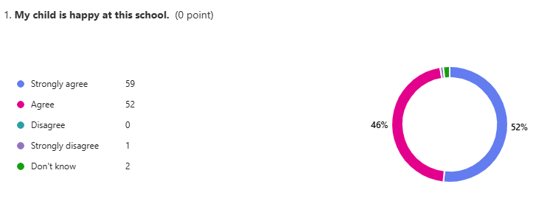
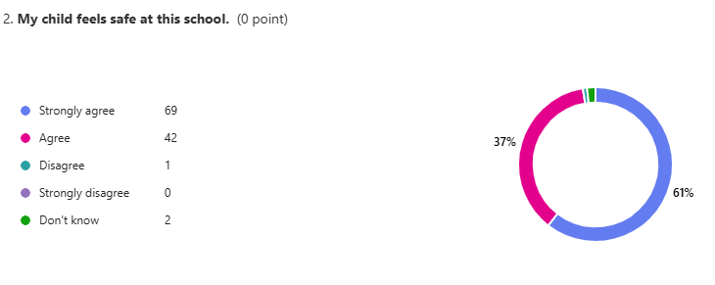
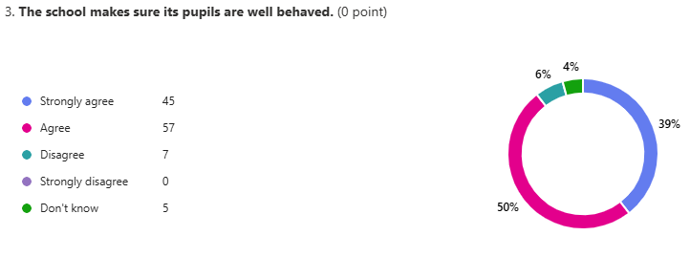
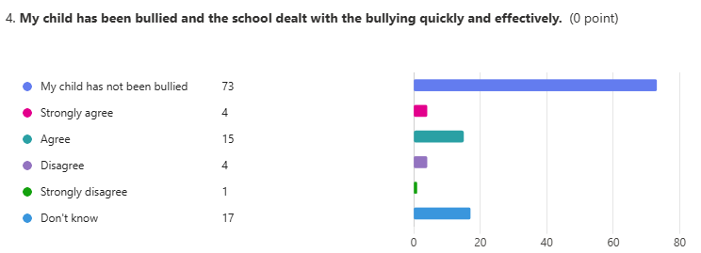
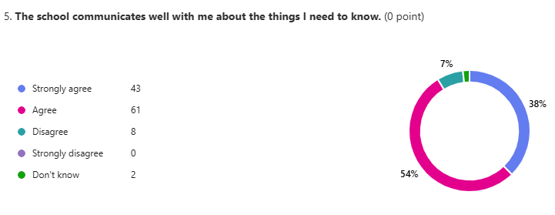
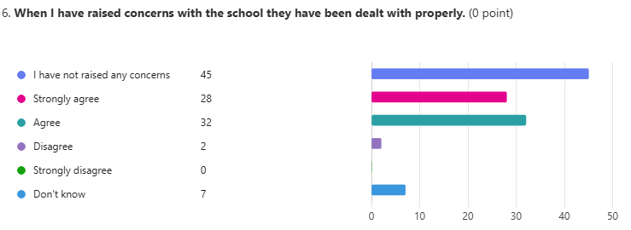
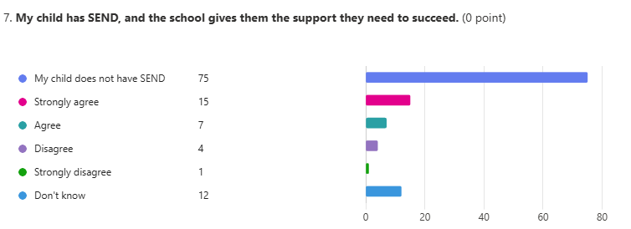
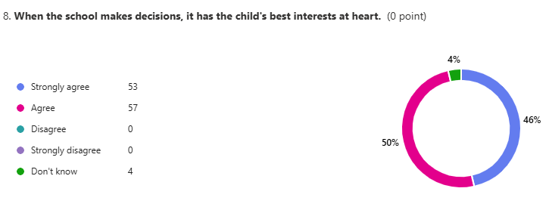
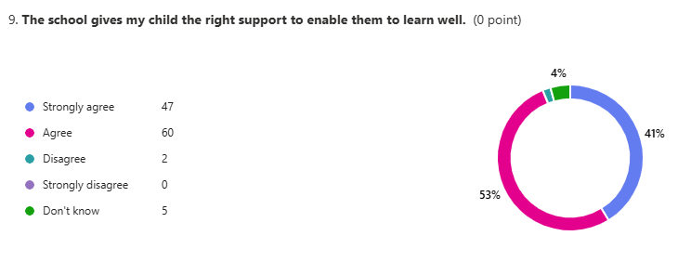
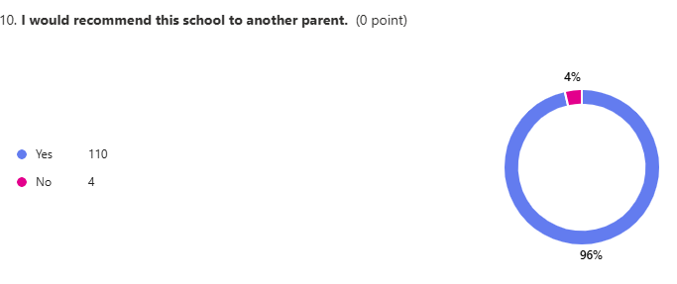

Things we are doing well…

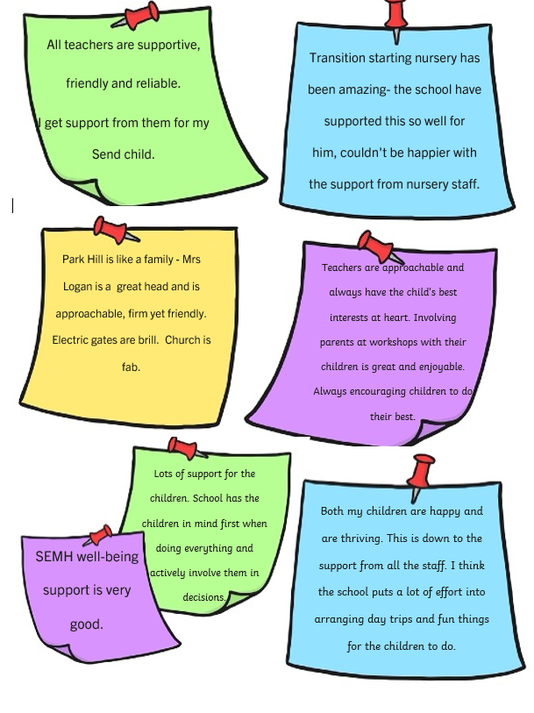
What we can do better…


